Exercise 2-4 Classifier

Jirayu Petchhan, D10907801

Import package(torch , torchvision, etc.)

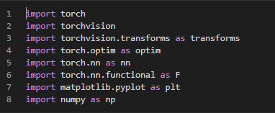

LeNet5 model

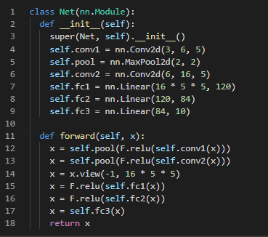

Unnormalize data and define model learning checkpoint finction

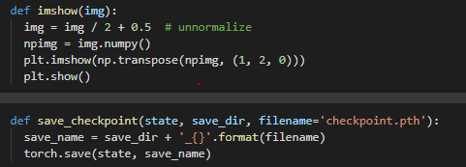

Transformation (Data pre-processing the image before feeding to network)

Selecting dataset (CIFAR10 from dataset inventory on torchvision framework)

Assign 10 classes for CIFAR10.

Net = model created (LeNet-5)

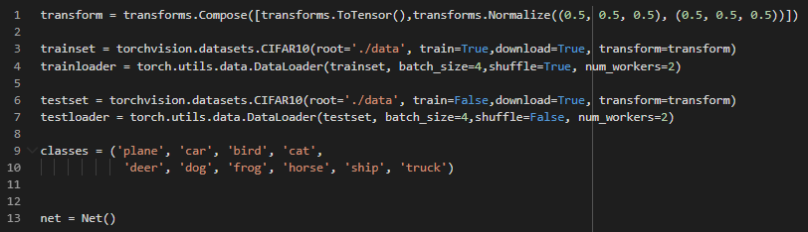

Loss (Cross-Entropy, softargmax) and optimizer(SGD) selection

Training process and backpropagation update setting up (default learning rate = 0.001)

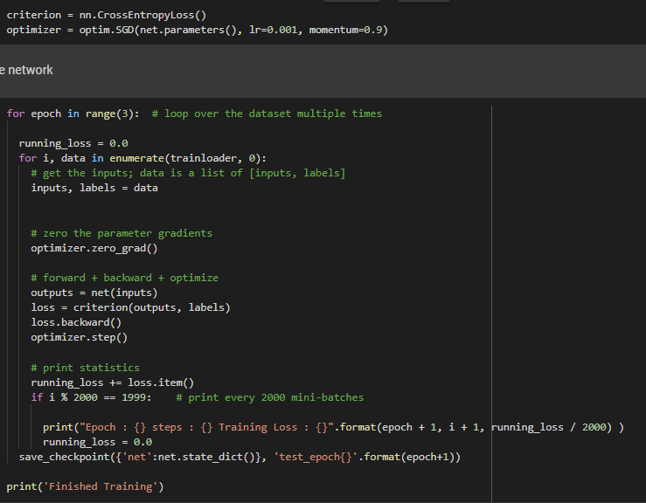

Dividing testing data in each iteration

Image prediction and accuracy rate of model

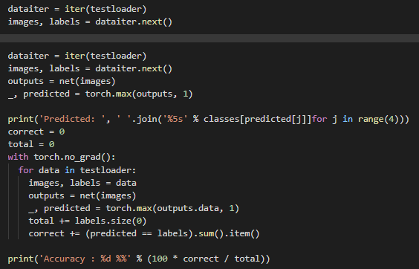

**Result**

Training in 5 epochs (10000 steps per epoch) as set up

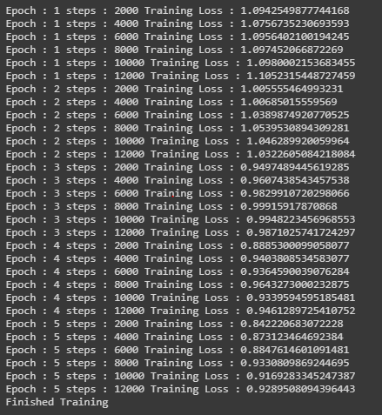

Lr = 0.001, accuracy = 61%



Training in 5 epochs (10000 steps per epoch) as set up



Lr = 0.01

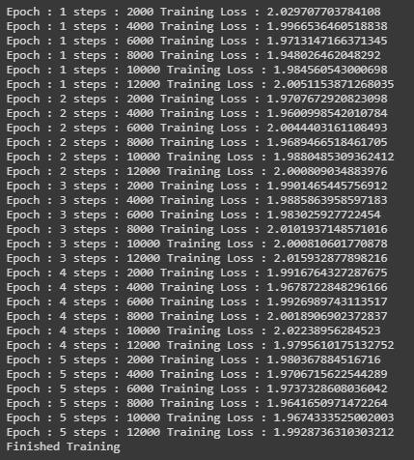

accuracy = 24%



Training in 5 epochs (10000 steps per epoch) as set up (the same as case of lr=0.001 and 0.01)



Lr = 0.1

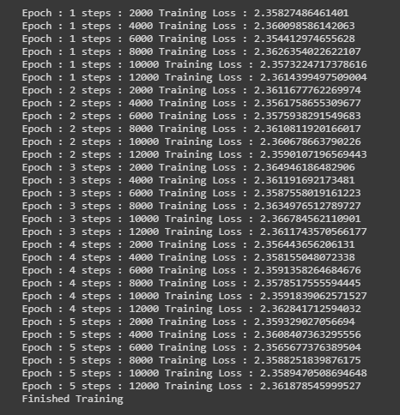

accuracy = 10%



**Conclusion**

If we try to increase more learning rate that’s cause the affect learning path can’t find the local optima point because the process of finding a suitable point will be skipped back and forth. Therefore, we have to set the learning rate appropriately e.g. lr=0.001.